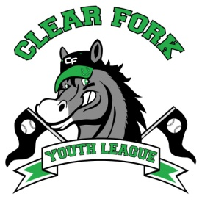
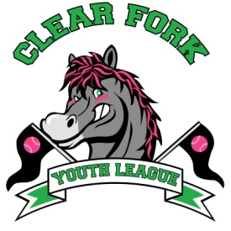
BOARD MEETING
JULY 10, 2019
Attendance:
Jay Vail
Josh Smith
Carrie Knight
Allen Leech
Ashley Ludwig
David Myers
Lindsay Roberts
Kyle Ludwig
Clint Knight

- Clint
  - Gave update on Funnel Cake 5K, 10K, 1M Race
  - Suggested we look at our contract with the village
- Jay
  - Set field clean up day for July 20 @ 9am
  - Field Auction for December 11
    - Allen will call Whatman Realtors and Auctioneers
  - Look into having our own opening day next season
- Josh Smith resigned as softball president
- Carrie Knight resigned as softball vice president

